Felicia Lauw

Who I am
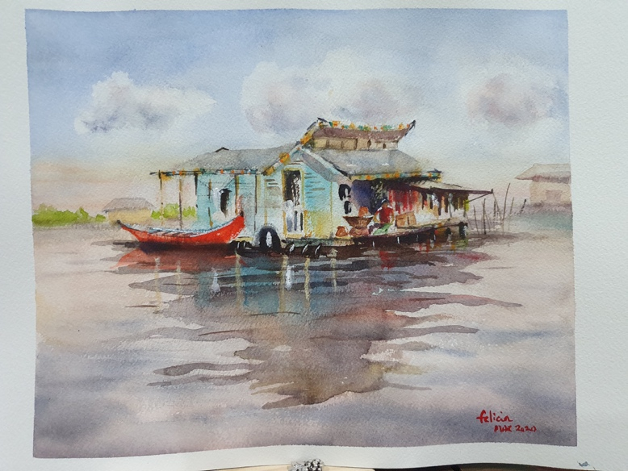
I feel most alive when I am engaged in deep meaningful conversations. My purpose is to bring clarity and ease to support the transition of growth and development in people, communities and systems. Growing up in Singapore and working nomadically and globally has provided a chance to build muscles of working with paradoxes, alignments and cultural diversity. I am grateful for the many teachers and opportunities in my life to re-consider some of my known and unknown habitual beliefs and gift myself with a chance to re-decide. In supervision, creating psychological safety to explore one’s practice with courage and candor in service of our clients, organization and community is really important to me.
I endeavor to see the world through the practice of watercolour pieces; the first wash, foreground, background, light and shadows to accentuate the focus object are all part of the beautiful composition of coaching supervision. Coaching supervision and painting are my anchors in continuous practice of compassion and kind intentions.
Having deep and reflective conversations and being available for and connecting with another person is fun for me, so I am grateful that I do not need that distinction between work and play. At the same time, I attend to my own person with a ritual of journaling, meditation, painting, yoga, walks and working with a supervisor to support me to be “fit for practice” and maintain consistent quality of work for my clients.

How I supervise
My tapestry of supervision work is made up of a paradoxical space of structure, pragmatism and expansive wondering. Labeled as an extreme introvert on certain psychometric assessment, I stretch myself with ease to hold space for enquiries, weaving the energetic field of head, heart and gut; have the confidence to get into the “not-knowing” space for insights from higher wisdom to emerge. In doing so, the other person leaves the conversation more aware, more awake and figuratively “come home to their brilliance.” Colleagues often describe me as “straight talking, quiet presence, firm and still”. Depending on where the conversations need, we explore the different layers of the situation and allowing what needs to emerge to come through, much like how different layers of pigment of watercolour works.

I believe that through authentic conversations and in relationship with each other, there is hope to bring more ease and joy back into our systems (organization, groups, teams and community). Very often in supervision, I exercise my courage muscle by leaning into tensions and shadows to uncover the hidden gold nuggets that is weaved in between the folds of people and situations. My experience on global transformation projects in Asia, China, France and United States has primed me well to continue to learn cultural graciousness when working with people of varied backgrounds. And years in management consulting and executive coaching gave me a good appreciation of systems and system dynamics.

I have been trained and is continuously learning different modalities, from the structured rationale models to the energetic, emotive and body works; these are all weaved into my practice. In short, I hope to attend to the whole person during the reflective dialogue of supervision to tap on the clients’ holistic wisdom and potential.

There is a myriad of reasons why people come for supervision and a few of those are offered (in no specific order, not mutually exclusive and not exhaustive):

- Commercial intricacy and Contracting within systems (1:1 or multi-party)
- Ethical Dilemmas
- Consistent quality of coaching
- Psychodynamics and Energetic Impact.

I am an accredited EMCC ESIA, ICF PCC and part of the EMCC Quality and Supervision workgroup, a representative of Association of Coaching Supervisors in APAC and a program leader for CSA India and China. I am currently supervising internal coaches of global companies, seasoned professional coaches and non-profit care management teams.

Felicia Lauw
https://linkedin.com//felicialauw


